**Part I: Script files**

1



**2**

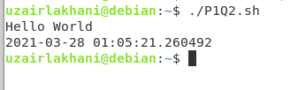

**Part II: Shell variables and input from users**

**1**

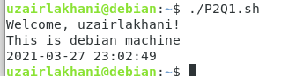

**2**

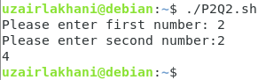

**Part III: Conditionals and loops**

1

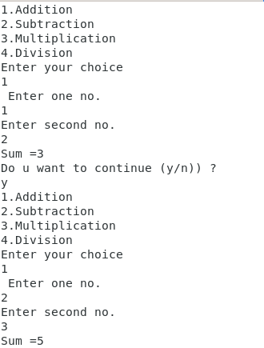

2



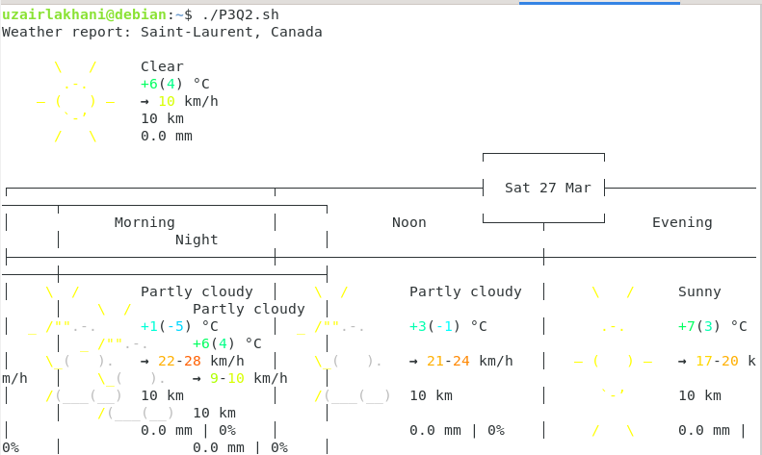

3

